**Data Visualization Exercise (Matplotlib )**

### Exercise 1: Read Total Sales of all months and show it using a line plotand take first 100 rows from data-frame.

Total Sales data provided for each month. Generated line plot must include the following properties: –

* X label name = Month
* Y label name = Sales

### Exercise Question 2: Get Total Sales of all months and show line plot with the following Style properties.

Generated line plot must include following Style properties: –

* Line Style dotted and Line-color should be red
* Take first 50 rows from data frame
* Show legend at the lower right location.
* X label name = Month Number
* Y label name = Sales or Price Each
* Add a circle marker.
* Line marker color as read
* Line width should be 3

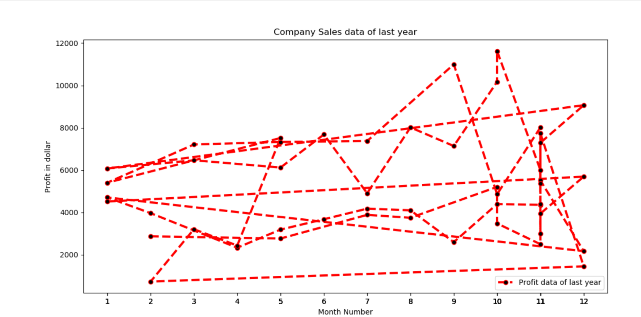fig. Sample for Exercise 2

### Exercise Question 3: Read motorcycle and classic car productline sales data and show it using a multiline plot and take first 100 rows from dataframe.

Display the number of units sold per month for each product using multiline plots. (i.e., Separate Plotline for each product for each product).

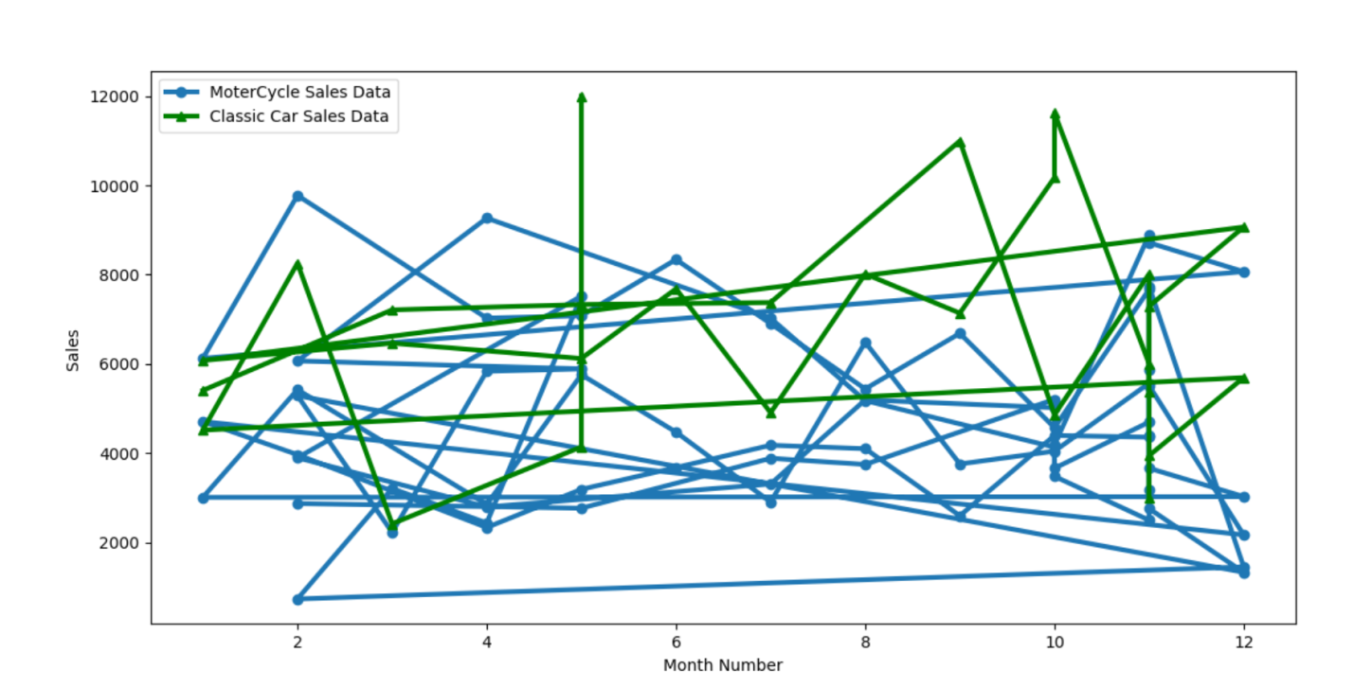

Fig: Sample for Exercise 3

### Exercise Question 4: Read Motorcycles sales data of each month and show it using a scatter plot and take first 100 rows from data frame.

Also, add a grid in the plot. gridline style should “–“.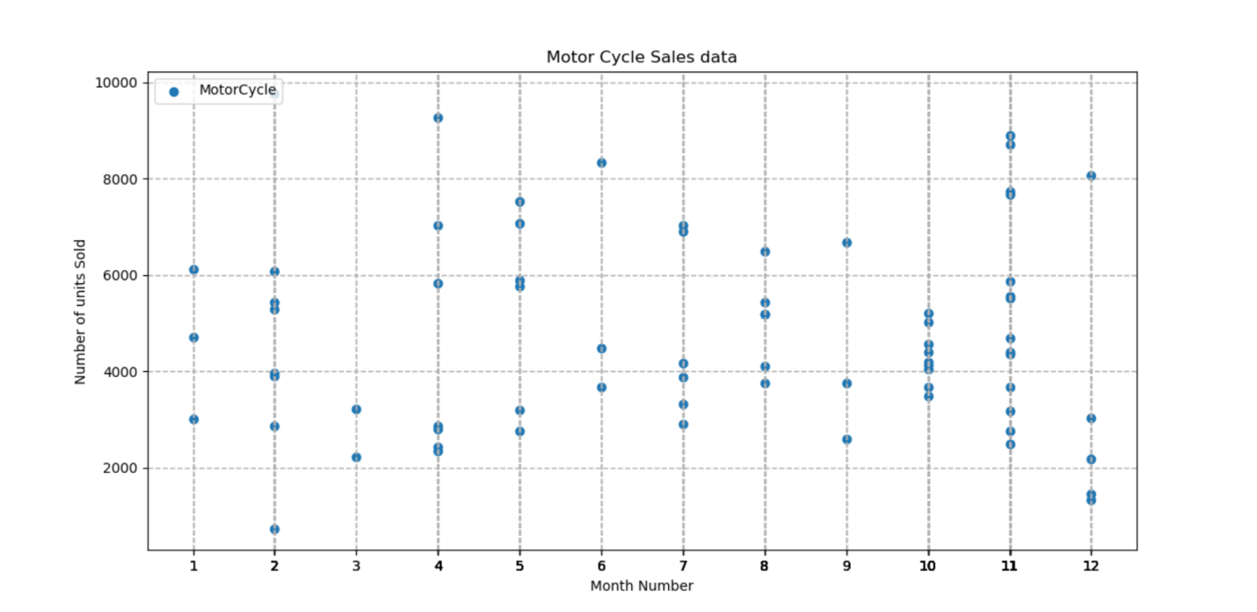

Fig: Sample for Exercise 4

### Exercise Question 5: Read Classic Cars and motorcycle data product sales data and show it using the bar chart and take first 100 rows from data frame.

Bar chart should display the number of units sold per month for each product. Add a separate bar for each product in the same chart.

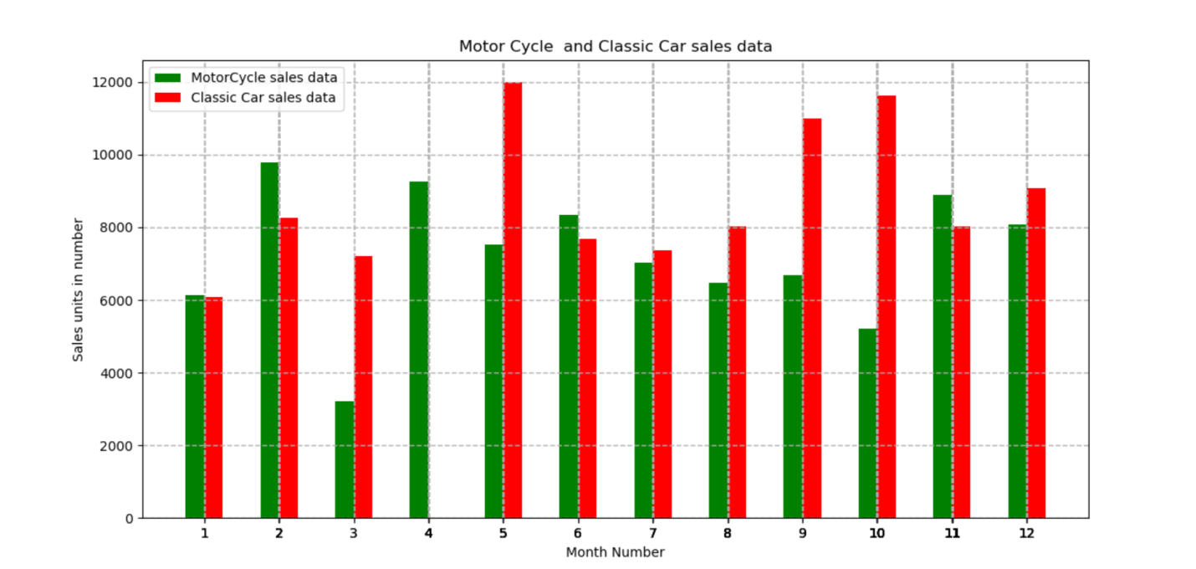

Fig: Sample for Exercise 5

### Exercise Question 6:Read classic car sales data of each month and show it using a bar plot and take first 100 rows from data frame.

### 

Fig: Sample for Exercise 6

### Exercise Question 7: Read the total sale of each month and show it using the histogram to see most common profit ranges

### 

Fig: Sample for Exercise 7

### Exercise Question 8: Calculate total sale data for motor cycle and classic car product and show it using a Pie chart take first 100 rows from dataframe.

### 

Fig: Sample for Exercise 8

### Exercise Question 9: Read motorcycle and classic car of all months and display it using the Subplot and take first 100 rows from dataframe.

### 

Fig: Sample for Exercise 9

### Exercise Question 10: Read Classic Cars,motorcycle,truck and bus and vintage car data product sales data and show it using the bar chart and take first 1000 rows from data frame.

Bar chart should display the number of units sold per month for each product. Add a separate bar for each product in the same chart.

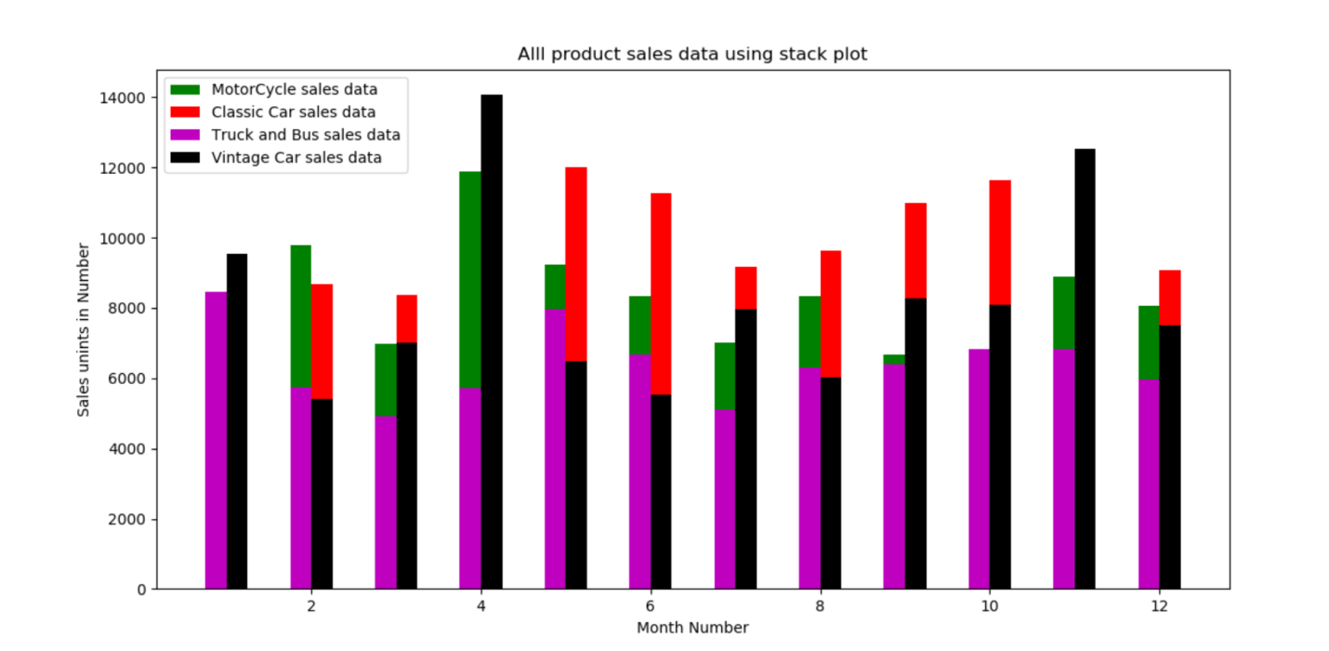

Fig: Sample for Exercise 10

### Exercise Question 11: Calculate total sale data for motor cycle ,classic car, truck and bus, vintage carproduct and show it using a Pie chart take first 1000 rows from data-frame.

### 

Fig: Sample for Exercise 11